PROJECT DOCUMENTATION REPORT
Online BookStore Management System
Using the MERN Stack (MongoDB · Express.js · React.js · Node.js)
Prepared by
Dubbaka Manasa
Frontend Development · UI Design · API Integration · Testing & Deployment
Venkateshwara Reddy Sangu
Backend Development · REST APIs · MongoDB Database · Authentication
Repository: github.com/manasa380/bookstore-mern
Live Demo: bookstore-mern-blond.vercel.app
July 2026

Table of Contents
1. Introduction 3
2. System Requirements 4
3. System Analysis 5
4. System Architecture 6
5. Database Design 8
6. Project Folder Structure 10
7. Installation & Setup Guide 11
8. Running the Application 12
9. API Documentation 13
10. Authentication & Security 16
11. User Interface & Module Description 17
12. Testing 19
13. Deployment 20
14. Screenshots & Live Demo Links 21
15. Known Issues & Limitations 21
16. Future Enhancements 22
17. Conclusion 22
18. References 23

1. Introduction

1.1 Purpose of the Project
The Online BookStore Management System is a full-stack web application built on the MERN stack (MongoDB, Express.js, React.js, and Node.js) that allows customers to browse, search, and purchase books online while giving administrators a dedicated dashboard to manage the book catalogue, orders, and users. The purpose of the project is to simulate a real-world e-commerce platform focused specifically on books, demonstrating a complete development lifecycle covering requirement analysis, UI/UX design, backend API development, database modelling, authentication, testing, and deployment.
The application is designed with two primary actors in mind: the end customer, who interacts with the storefront to discover and purchase books, and the administrator, who is responsible for maintaining inventory, tracking orders, and monitoring overall store activity. By separating these two concerns into a customer-facing module and an admin module, the system reflects the architecture used by production-grade e-commerce platforms.

1.2 Scope of the Project
The scope of the system covers the core functional areas of an online bookstore:
- User registration, login, and profile management secured using JSON Web Tokens (JWT).
- A catalogue of books with search, filter, and detail-view capability.
- A shopping cart that persists items selected by the logged-in user.
- A wishlist feature that allows users to save books for later purchase.
- An order placement and order-history module.
- A review and rating system so customers can share feedback on books they have purchased.
- An administrator dashboard for managing books, orders, and users.
The scope does not currently extend to a live payment gateway integration, third-party social login, or automated recommendation systems — these are documented as future enhancements in Section 16.

1.3 Existing System vs. Proposed System
Aspect | Existing / Traditional Approach | Proposed MERN System
Book discovery | Manual catalogues, physical stores, or static websites | Dynamic, searchable digital catalogue with real-time data
Order management | Manual or spreadsheet-based tracking | Automated order lifecycle stored in MongoDB with order history
Scalability | Difficult to scale without re-engineering | Stateless REST API and NoSQL database scale horizontally
Accessibility | Limited to physical location or basic website | Accessible from any device via responsive React frontend
Administration | Manual stock-keeping | Centralized admin dashboard for books, orders, and users

2. System Requirements

2.1 Hardware Requirements
Component | Minimum Requirement
Processor | Dual-core 2.0 GHz or higher
RAM | 4 GB (8 GB recommended for smooth development)
Storage | 1 GB free space for source code, dependencies, and logs
Internet Connection | Required for MongoDB Atlas, npm registry, and deployment services

2.2 Software Requirements
Category | Technology / Tool | Purpose
Runtime | Node.js (v18+) | Executes the Express.js backend server
Package Manager | npm | Installs and manages project dependencies
Frontend Library | React.js (via Vite) | Builds the component-based single-page application
Styling | Tailwind CSS | Utility-first responsive styling
Backend Framework | Express.js | Handles HTTP routing and middleware
Database | MongoDB (Atlas / local) | Stores users, books, carts, orders, and reviews
ODM | Mongoose | Schema definition and data validation for MongoDB
Authentication | JSON Web Token (JWT) + bcrypt | Secures user sessions and hashes passwords
Version Control | Git & GitHub | Source code management and collaboration
Deployment | Vercel (frontend), Render (backend) | Hosting the production build of the application
Code Editor | Visual Studio Code | Primary development environment
API Testing | Postman | Manual verification of REST endpoints

3. System Analysis

3.1 Feasibility Study

3.1.1 Technical Feasibility
All technologies used (React, Node.js, Express.js, MongoDB) are open-source, well-documented, and widely adopted in the industry, which makes the system technically feasible to build, maintain, and extend. The chosen stack also allows the team to use a single language, JavaScript, across both the frontend and backend, reducing context-switching during development.

3.1.2 Economic Feasibility
The project relies entirely on free or free-tier services — MongoDB Atlas free cluster, Vercel free hosting for the frontend, and Render free web service for the backend — making the system economically feasible for an academic or small-scale commercial deployment with no licensing costs.

3.1.3 Operational Feasibility
The interface is designed to be intuitive for both customers and administrators, requiring minimal training. Standard e-commerce interaction patterns (cart, wishlist, checkout) are used so that end users are already familiar with the workflow from other online shopping experiences.

3.2 Functional Modules
The system is decomposed into the following functional modules, each aligned to a REST API resource on the backend and a corresponding page or component on the frontend:
- User Module — registration, login, profile view/update, logout.
- Book Catalogue Module — list, search, filter, and view book details.
- Cart Module — add, update quantity, remove, and view cart items.
- Wishlist Module — add/remove books to a personal wishlist.
- Order Module — checkout, order placement, and order history.
- Review Module — submit and view ratings/reviews for a book.
- Admin Module — manage books (CRUD), view/update orders, manage users.

3.3 Use Case Overview
Actor | Use Cases
Customer (Registered User) | Register/Login, Browse Books, Search & Filter, View Book Details, Add to Cart, Add to Wishlist, Checkout, View Order History, Submit Review, Update Profile
Administrator | Login, Add/Edit/Delete Book, View All Orders, Update Order Status, View/Manage Users, View Dashboard Statistics
Guest (Unauthenticated) | Browse Books, View Book Details, Register

4. System Architecture

4.1 Architectural Overview
The system follows a three-tier client–server architecture, which cleanly separates presentation, business logic, and data storage:
- Presentation Tier — A React single-page application (SPA), bundled with Vite and styled using Tailwind CSS, that runs in the user's browser and communicates with the backend exclusively through REST API calls.
- Application/Logic Tier — A Node.js runtime hosting an Express.js server that exposes REST endpoints, applies authentication middleware, validates requests, and implements business logic.
- Data Tier — A MongoDB NoSQL database, accessed through Mongoose object models, that persistently stores users, books, carts, wishlists, orders, and reviews.

4.1.1 Request Flow
A typical request flows through the system as follows: (1) the React client dispatches an HTTP request (e.g., GET /api/books) using fetch or Axios; (2) the Express.js server routes the request to the appropriate controller through defined route files; (3) middleware such as the JWT authentication guard verifies the request where required; (4) the controller invokes the relevant Mongoose model to query or update MongoDB; (5) the server returns a JSON response; (6) the React client updates component state and re-renders the relevant UI.

4.2 Technology Stack
Layer | Technology | Role in the System
Frontend | React.js + Vite | Component-based UI and fast development/build tooling
Styling | Tailwind CSS | Responsive, utility-first design system
Routing (Client) | React Router | Client-side page navigation without full reloads
Backend | Node.js + Express.js | REST API server and business logic
Database | MongoDB | Document-oriented storage for all persistent data
ODM | Mongoose | Schema validation and query building for MongoDB
Authentication | JWT + bcrypt | Stateless session tokens and secure password storage
Hosting (Frontend) | Vercel | Production hosting of the built React application
Hosting (Backend) | Render | Production hosting of the Express.js API server

4.3 High-Level Architecture Diagram
Layer | Component | Description
Client | Browser (React SPA) | Renders pages: Home, Books, Cart, Wishlist, Checkout, Orders, Profile, Admin
Network | HTTPS / REST (JSON) | Communication channel between client and server
Server | Express.js API (Node.js) | Routes: /api/auth, /api/books, /api/cart, /api/wishlist, /api/orders, /api/reviews
Middleware | JWT Auth Guard | Protects private routes and identifies the requesting user
Database | MongoDB Atlas | Collections: users, books, carts, wishlists, orders, reviews
Figure 4.1 — Logical layers of the MERN BookStore architecture
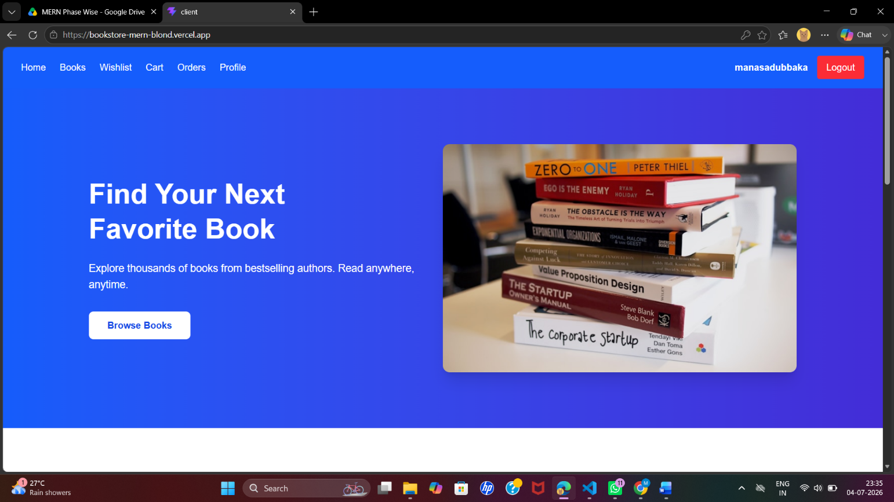

5. Database Design
The database is implemented in MongoDB using Mongoose schemas that define validation rules and relationships (via ObjectId references) between collections. The following subsections describe the primary collections used by the application.

5.1 User Collection
Field | Type | Description
_id | ObjectId | Unique identifier auto-generated by MongoDB
name | String | Full name of the user
email | String (unique) | Login identifier, validated and indexed
password | String (hashed) | bcrypt-hashed password, never stored in plaintext
role | String (enum: user, admin) | Determines access level
createdAt | Date | Timestamp of account creation

5.2 Book Collection
Field | Type | Description
_id | ObjectId | Unique identifier for the book
title | String | Title of the book
author | String | Author name
description | String | Detailed description/synopsis
price | Number | Selling price
category | String | Genre/category used for filtering
imageUrl | String | URL of the book cover image
stock | Number | Available quantity
ratingsAverage | Number | Aggregated average rating from reviews

5.3 Cart Collection
Field | Type | Description
_id | ObjectId | Unique identifier for the cart document
user | ObjectId (ref: User) | Owner of the cart
items | Array<{ book: ObjectId, quantity: Number }> | List of books and quantities in the cart
updatedAt | Date | Last time the cart was modified

5.4 Wishlist Collection
Field | Type | Description
_id | ObjectId | Unique identifier for the wishlist document
user | ObjectId (ref: User) | Owner of the wishlist
books | Array<ObjectId> (ref: Book) | Books saved for later purchase

5.5 Order Collection
Field | Type | Description
_id | ObjectId | Unique identifier for the order
user | ObjectId (ref: User) | Customer who placed the order
items | Array<{ book: ObjectId, quantity: Number, price: Number }> | Snapshot of purchased items
totalAmount | Number | Total value of the order
status | String (enum: pending, processing, shipped, delivered) | Current fulfilment status
shippingAddress | String | Delivery address supplied at checkout
createdAt | Date | Order placement timestamp

5.6 Review Collection
Field | Type | Description
_id | ObjectId | Unique identifier for the review
book | ObjectId (ref: Book) | Book being reviewed
user | ObjectId (ref: User) | Author of the review
rating | Number (1–5) | Star rating given by the user
comment | String | Free-text feedback
createdAt | Date | Timestamp of submission

5.7 Entity Relationships
A User can own exactly one Cart and one Wishlist, and can place many Orders and submit many Reviews (one-to-many relationships). A Book can appear in many Carts, many Wishlists, many Order line items, and receive many Reviews. These relationships are implemented using Mongoose ObjectId references and resolved at query time using the .populate() method, allowing the API to return enriched JSON responses that include book or user details alongside the referencing document.
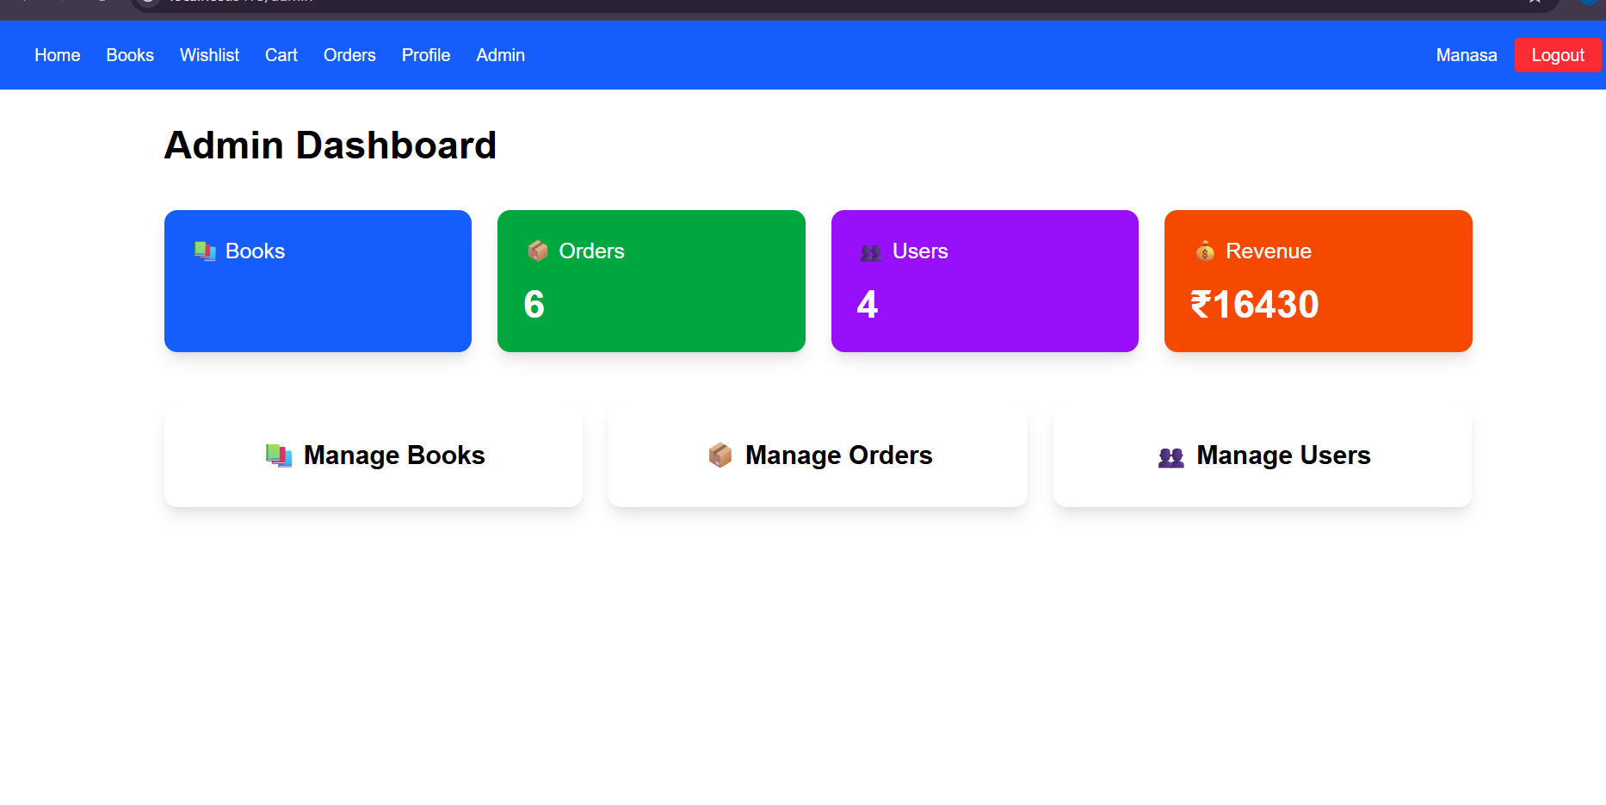

6. Project Folder Structure
The repository is organised as a monorepo with two top-level directories, client (React frontend) and server (Express backend), enabling independent development, dependency management, and deployment of each tier.

6.1 Client (Frontend) Structure
Folder / File | Purpose
src/components | Reusable UI building blocks (Navbar, BookCard, Footer, etc.)
src/pages | Top-level route pages (Home, Books, Cart, Wishlist, Checkout, Orders, Profile, Admin)
src/routes | React Router route definitions and protected-route wrappers
src/services | Axios/fetch wrapper functions that call the backend REST API
src/context / hooks | Global state (auth context, cart context) and custom hooks
public | Static assets served as-is (favicon, static images)
.env | Environment variables such as the backend API base URL

6.2 Server (Backend) Structure
Folder / File | Purpose
config | Database connection setup and environment configuration
controllers | Business logic for each resource (authController, bookController, etc.)
middleware | JWT authentication guard, error handler, request validation
models | Mongoose schemas for User, Book, Cart, Wishlist, Order, Review
routes | Express Router definitions mapping URLs to controller functions
.env | Environment variables — MongoDB URI, JWT secret, port number
server.js / index.js | Application entry point that initializes Express and connects to MongoDB

7. Installation & Setup Guide
The following steps describe how to set up the project in a local development environment.

Step 1 — Prerequisites
- Install Node.js (v18 or later) and npm from nodejs.org.
- Install Git for cloning the repository.
- Create a free MongoDB Atlas cluster, or install MongoDB locally.

Step 2 — Clone the Repository
git clone https://github.com/manasa380/bookstore-mern.git

Step 3 — Install Dependencies
Install dependencies separately for the client and server, since they are managed as independent npm projects:
cd client && npm install
cd ../server && npm install

Step 4 — Configure Environment Variables
Create a .env file inside the server directory with the following keys:
Variable | Description
MONGO_URI | MongoDB Atlas / local connection string
JWT_SECRET | Secret key used to sign and verify JWT tokens
PORT | Port on which the Express server listens (e.g., 5000)
Similarly, create a .env file inside the client directory containing the backend API base URL, e.g. VITE_API_URL=http://localhost:5000/api.
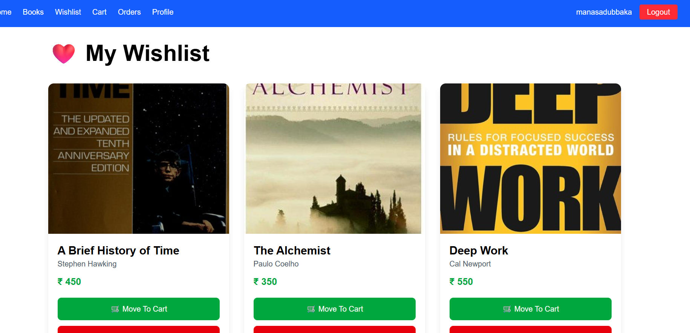

8. Running the Application

8.1 Development Mode
Start the backend server:
cd server npm run dev
In a separate terminal, start the frontend development server:
cd client npm run dev
By default, Vite serves the React application at http://localhost:5173, and Express listens on the port defined in the server's .env file (typically 5000). The frontend is configured to route all API requests to the backend base URL.

8.2 Production Mode
For production, the client is built into static assets using npm run build, and the resulting build folder is deployed to Vercel. The server is deployed as a persistent Node.js web service on Render, connected to a MongoDB Atlas cluster rather than a local database.

9. API Documentation
All endpoints are prefixed with /api and exchange data in JSON format. Protected endpoints require an Authorization: Bearer <token> header containing a valid JWT issued at login.

9.1 Authentication APIs
Method | Endpoint | Access | Description
POST | /api/auth/register | Public | Registers a new user account
POST | /api/auth/login | Public | Authenticates a user and returns a JWT
GET | /api/auth/profile | Private | Returns the profile of the logged-in user
PUT | /api/auth/profile | Private | Updates the logged-in user's profile details

9.2 Book APIs
Method | Endpoint | Access | Description
GET | /api/books | Public | Retrieves the full list of books (supports search/filter query params)
GET | /api/books/:id | Public | Retrieves details of a single book
POST | /api/books | Admin | Creates a new book listing
PUT | /api/books/:id | Admin | Updates an existing book listing
DELETE | /api/books/:id | Admin | Removes a book from the catalogue

9.3 Cart APIs
Method | Endpoint | Access | Description
GET | /api/cart | Private | Retrieves the current user's cart
POST | /api/cart | Private | Adds a book to the cart
PUT | /api/cart/:itemId | Private | Updates quantity of a cart item
DELETE | /api/cart/:itemId | Private | Removes an item from the cart

9.4 Wishlist APIs
Method | Endpoint | Access | Description
GET | /api/wishlist | Private | Retrieves the current user's wishlist
POST | /api/wishlist/:bookId | Private | Adds a book to the wishlist
DELETE | /api/wishlist/:bookId | Private | Removes a book from the wishlist

9.5 Order APIs
Method | Endpoint | Access | Description
POST | /api/orders | Private | Places a new order from the current cart
GET | /api/orders | Private | Retrieves the order history of the logged-in user
GET | /api/orders/:id | Private | Retrieves details of a specific order
GET | /api/orders/all | Admin | Retrieves all orders placed on the platform
PUT | /api/orders/:id/status | Admin | Updates the fulfilment status of an order

9.6 Review APIs
Method | Endpoint | Access | Description
GET | /api/reviews/:bookId | Public | Retrieves all reviews for a specific book
POST | /api/reviews/:bookId | Private | Submits a new review/rating for a book
DELETE | /api/reviews/:id | Private | Deletes a review submitted by the current user

9.7 Sample Response Format
All API responses follow a consistent JSON envelope, illustrated below for a successful book-fetch request:
{ "success": true, "data": { "_id": "665f1c...", "title": "The Silent Patient", "author": "Alex Michaelides", "price": 399, "category": "Thriller", "stock": 12 } }

10. Authentication & Security

10.1 Password Security
User passwords are never stored in plaintext. Before saving a new user document, the password is hashed using bcrypt with a configurable salt round count, ensuring that even in the event of a database breach, original passwords cannot be trivially recovered.

10.2 Token-Based Authentication
Upon successful login, the server generates a signed JSON Web Token (JWT) containing the user's identifier and role, using a secret key stored in the server's environment variables. This token is returned to the client and must be attached to the Authorization header of subsequent requests to protected endpoints. The server verifies the token's signature and expiry on every protected request using an authentication middleware before allowing the request to proceed to the controller.

10.3 Role-Based Access Control
Every user document carries a role field (user or admin). Admin-only routes — such as creating, updating, or deleting books, and viewing all orders — are protected by an additional middleware layer that checks the decoded token's role claim, rejecting the request with a 403 Forbidden response if the caller is not an administrator.

10.4 Additional Security Practices
- Environment variables (.env) are used to keep secrets such as the MongoDB URI and JWT secret out of the source code.
- CORS is configured on the Express server to restrict cross-origin requests to the deployed frontend domain.
- Centralized error-handl11. User Interface & Module Description
The frontend is built as a responsive single-page application using React, Vite, and Tailwind CSS. Each of the following pages corresponds to a route managed by React Router.

Home
Landing page introducing the store, highlighting featured or newly added books, and providing quick navigation into the catalogue.

Books (Catalogue)
Displays the full book listing with search and category filters, allowing customers to quickly locate titles of interest.

Book Details
Shows full information about a selected book — description, price, stock availability, average rating, and customer reviews — along with actions to add the book to the cart or wishlist.

Cart
Lists all books currently added by the user with quantity controls, a running subtotal, and a checkout action.

Wishlist
Displays books the user has saved for later, with an option to move any item directly into the cart.

Checkout
Collects shipping details and confirms the order summary before the order is submitted to the backend.

Orders
Shows the logged-in user's order history along with the current status of each order (pending, processing, shipped, delivered).

Profile
Allows the user to view and update their personal account details.

Admin Dashboard
A restricted area for administrators to add, edit, or remove books, review incoming orders, update order status, and manage registered users.
Note: This section describes each interface module as implemented in the application. Corresponding screenshots of these pages should be inserted here in the final published copy of this report — see Section 14 for placeholder guidance and live demo links where the actual UI can be viewed.
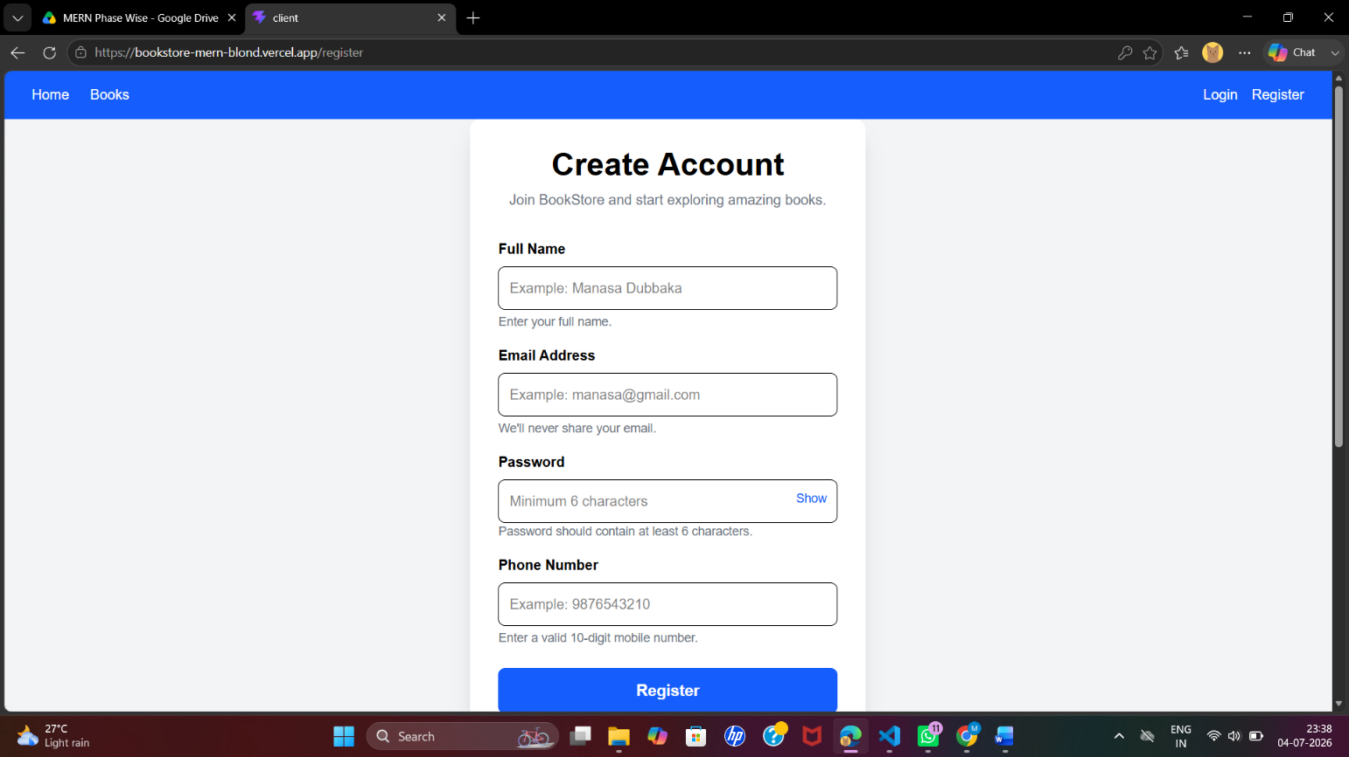

12. Testing

12.1 Testing Approach
Testing was carried out manually across all major modules of the application, covering both the customer-facing flows and the administrator workflows. Each REST endpoint was independently verified using Postman before being integrated with the frontend, and each page was then tested end-to-end through the browser to confirm that UI actions correctly triggered the expected API calls and state updates.

12.2 Sample Test Cases
Test ID | Module | Test Scenario | Expected Result | Status
TC-01 | Auth | Register with a valid, unused email | Account created, redirected to login | Pass
TC-02 | Auth | Login with incorrect password | Error message displayed, no token issued | Pass
TC-03 | Books | Search for a book by title keyword | Matching results shown in catalogue | Pass
TC-04 | Cart | Add the same book twice | Quantity increments instead of duplicate entry | Pass
TC-05 | Wishlist | Add a book to wishlist while logged out | Redirected to login page | Pass
TC-06 | Checkout | Place an order with an empty cart | Checkout action blocked with a warning | Pass
TC-07 | Orders | View order history after placing an order | New order appears with status 'pending' | Pass
TC-08 | Reviews | Submit a review without a rating value | Validation error returned by the API | Pass
TC-09 | Admin | Non-admin user attempts to delete a book | Request rejected with 403 Forbidden | Pass
TC-10 | Book Images | Add a book with an invalid image URL | Broken image placeholder shown on catalogue | Known Issue

12.3 Testing Summary
All core functional flows across authentication, catalogue browsing, cart, wishlist, checkout, order history, and the review system passed manual verification. The one recurring issue identified relates to book cover images depending on externally supplied URLs rather than an integrated image-hosting service, which is discussed further in Section 15.

13. Deployment

13.1 Frontend Deployment (Vercel)
The React client is deployed on Vercel. Vercel automatically builds the project using npm run build and serves the resulting static assets over a global CDN, providing HTTPS and continuous deployment whenever changes are pushed to the connected GitHub branch.

13.2 Backend Deployment (Render)
The Express.js server is deployed as a web service on Render, which installs dependencies, runs the start script, and keeps the Node.js process alive to continuously serve API requests. Environment variables such as the MongoDB connection string and JWT secret are configured securely within Render's dashboard rather than being committed to source control.

13.3 Database Hosting (MongoDB Atlas)
The production database is hosted on MongoDB Atlas, a managed cloud database service, which provides automated backups, monitoring, and secure network access rules restricting connections to trusted IP ranges and application credentials.

13.4 Deployment URLs
Component | URL
Source Code Repository | https://github.com/manasa380/bookstore-mern
Live Frontend Application | https://bookstore-mern-blond.vercel.app/
Live Backend API | https://bookstore-mern-azil.onrender.com

14. Screenshots & Live Demo Links
The following pages of the deployed application should be captured as screenshots and inserted into this section for the final published report: Home, Books (Catalogue), Book Details, Cart, Wishlist, Checkout, Orders, Profile, and the Admin Dashboard. Since this document was generated from the project's outline, placeholders are listed below in place of the images; each can be replaced with an actual screenshot captured from the live deployment.
[ Placeholder for screenshot — Home Page ]
[ Placeholder for screenshot — Books Catalogue ]
[ Placeholder for screenshot — Book Details Page ]
[ Placeholder for screenshot — Cart Page ]
[ Placeholder for screenshot — Wishlist Page ]
[ Placeholder for screenshot — Checkout Page ]
[ Placeholder for screenshot — Orders / Order History Page ]
[ Placeholder for screenshot — User Profile Page ]
[ Placeholder for screenshot — Admin Dashboard ]
Live demonstration links:
- GitHub Repository — https://github.com/manasa380/bookstore-mern
- Frontend (Live) — https://bookstore-mern-blond.vercel.app/
- Backend API (Live) — https://bookstore-mern-azil.onrender.com

15. Known Issues & Limitations
# | Issue | Impact | Notes
1 | Book cover images depend on externally supplied URLs | Broken or missing images if the URL is invalid or the source goes offline | Planned resolution via Cloudinary integration (see Section 16)
2 | No live payment gateway | Orders are recorded but real payments cannot currently be processed | Planned resolution via Razorpay integration (see Section 16)

16. Future Enhancements

Cloudinary Integration
Replace externally hosted image URLs with a managed image-upload and delivery pipeline, removing the current dependency on third-party links for book cover art.

Razorpay Payment Gateway
Integrate a real payment gateway so that checkout results in an actual, securely processed transaction rather than a recorded order only.

Google Login (OAuth)
Allow users to register and log in using their Google account for a faster, password-less onboarding experience.

AI-Based Recommendations
Suggest books to users based on their browsing history, purchase history, and ratings, using a recommendation model.

PDF Invoice Generation
Automatically generate a downloadable PDF invoice for each completed order.

Order Tracking
Provide real-time status updates for shipped orders, potentially integrating with a courier tracking API.

17. Conclusion
The Online BookStore Management System successfully demonstrates the design and implementation of a full-stack e-commerce application using the MERN stack. Through the combination of a React-based responsive frontend, a Node.js/Express.js REST API backend, and a MongoDB document database, the project delivers a working platform that covers authentication, catalogue browsing, cart and wishlist management, order placement, and a review system, alongside a dedicated administrative dashboard.
The system was built collaboratively, with frontend development, UI design, API integration, testing, and deployment handled by Dubbaka Manasa, and backend development, REST API design, database modelling, and authentication handled by Venkateshwara Reddy Sangu. The project is deployed and publicly accessible, with the source code, live frontend, and live backend all linked in Section 13.4, and provides a solid foundation for the future enhancements outlined in Section 16.

18. References
- React Documentation — https://react.dev
- Vite Documentation — https://vitejs.dev
- Tailwind CSS Documentation — https://tailwindcss.com
- Express.js Documentation — https://expressjs.com
- Node.js Documentation — https://nodejs.org
- MongoDB Documentation — https://www.mongodb.com/docs
- Mongoose Documentation — https://mongoosejs.com
- JSON Web Tokens — https://jwt.io
- Project Repository — https://github.com/manasa380/bookstore-mern

